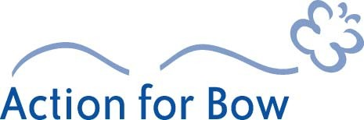

Application form

Project Name:
Start Date: End Date:
Delivery Organisation:
Status – Charity, Company etc.:
Project Manager:
Address:
Telephone Number: Email:
Total Project Cost: Grant Requested:
Match Funding
Organisation | Amount | Confirmed?
Match Funding Total

Proposed Project Description (what will be provided, by whom, to whom, and where?)

Target Beneficiaries and Outputs (please refer to outputs schedule for appropriate codes)
Age Group | Male | Female | Output Description | Code

continued…
Itemised breakdown of costs | Amount

Total

Please tell us about your experience in providing these activities

What are your plans for the future sustainability of this project?

General Conditions
- Applications can only accepted for services that will benefit the residents of Bow West or Bow East Wards.
- Grants are only payable after the projects outputs have been delivered.
- Payments cannot be made to individuals.
- Reports will be required on the outputs delivered and expenditure made, and for the Trust’s annual report.
- Projects will be subject to monitoring visits by a representative of Action for Bow.

For Office Use
Previous Support:

Appraisal Panel Comments:

Funding Recommendation:

